PROGRAM 1: 8-PUZZLE PROBLEM
Aim
The aim of this experiment is to solve the 8-Puzzle Problem using the Breadth First Search (BFS) algorithm
Objective
To arrange the tiles in the correct order by moving the blank space.
Algorithm
Algorithm: EightPuzzleBFS()
Step 1: Start.
Step 2: Define the initial state and the goal state of the puzzle.
Step 3: Create an empty queue.
Step 4: Insert the initial state into the queue.
Step 5: Create an empty visited set.
Step 6: Repeat until the queue becomes empty.
Remove the front state from the queue.
If the current state is already visited,
Continue with the next state.
Mark the current state as visited.
If the current state is equal to the goal state,
Display the solution path.
Stop.
Locate the blank tile (0).
Generate all valid neighboring states by moving
the blank tile Up, Down, Left or Right.
Insert every unvisited neighboring state into the queue.
Step 7: If no solution exists,
Display "No Solution Found."
Step 8: Stop.

SOURCE CODE:
import heapq
print("192311187 – N.Sai Sankar");
goal = [(1,2,3),(4,5,6),(7,8,0)]

def heuristic(state):
dist = 0
for i in range(3):
for j in range(3):
val = state[i][j]
if val == 0: continue
x, y = divmod(val-1, 3)
dist += abs(x - i) + abs(y - j)
return dist

def neighbors(state):
x, y = [(ix,iy) for ix,row in enumerate(state) for iy,v in enumerate(row) if v==0][0]
moves = []
for dx, dy in [(-1,0),(1,0),(0,-1),(0,1)]:
nx, ny = x+dx, y+dy
if 0<=nx<3 and 0<=ny<3:
new = [list(r) for r in state]
new[x][y], new[nx][ny] = new[nx][ny], new[x][y]
moves.append(tuple(tuple(r) for r in new))
return moves

def a_star(start):
heap = [(heuristic(start), 0, start, [])]
visited = set()
while heap:
est, cost, state, path = heapq.heappop(heap)
if state == tuple(tuple(r) for r in goal):
return path + [state]
if state in visited: continue
visited.add(state)
for nxt in neighbors(state):
if nxt not in visited:
heapq.heappush(heap, (cost+1+heuristic(nxt), cost+1, nxt, path + [state]))
return None

# Example
start = ((1,2,3),(4,0,6),(7,5,8))
solution = a_star(start)
for i, s in enumerate(solution):
print(f"Step {i}:\n" + "\n".join(str(row) for row in s), "\n")

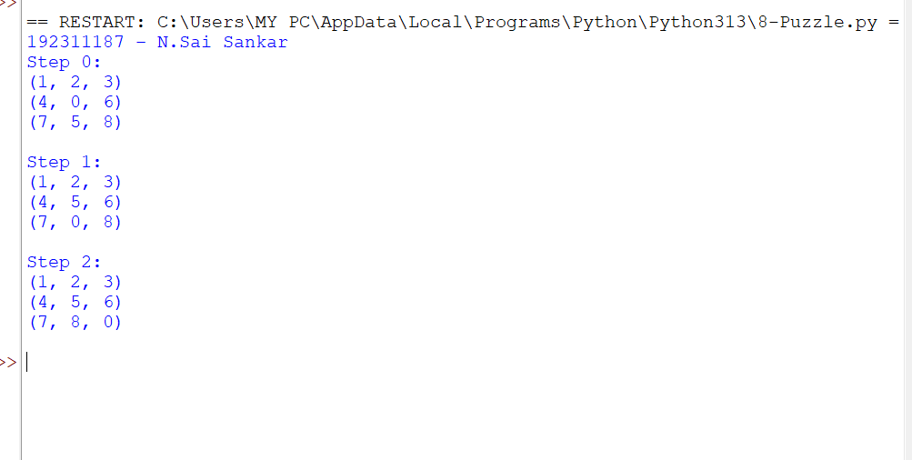

Result:
Hence, the simple python program for 8- puzzle is done

2. Queen Problem

Aim: To solve the 8-Queen problem using the Backtracking algorithm.

Algorithm:
- Start with the first row.
- Place a queen in a safe column.
- Move to the next row.
- If a safe position is found, place the queen.
- If no safe position exists, backtrack to the previous row.
- Repeat until all eight queens are placed.
- Display the solution.

Source Code:
print("192311189 - Mahesh Babu")
print("Enter the number of queens:")
N = int(input())
board = [[0] * N for _ in range(N)]
def attack(i, j):
# Check row and column
for k in range(N):
if board[i][k] == 1 or board[k][j] == 1:
return True
# Check diagonals
for k in range(N):
for l in range(N):
if (k + l == i + j) or (k - l == i - j):
if board[k][l] == 1:
return True
return False
def N_queens(n):
if n == 0:
return True
for i in range(N):
for j in range(N):
if (not attack(i, j)) and (board[i][j] != 1):
board[i][j] = 1
if N_queens(n - 1):
return True
board[i][j] = 0
return False
# Solve the problem
if N_queens(N):
print("\nSolution:")
for row in board:
print(row)
else:
print("No solution exists.")
Output:
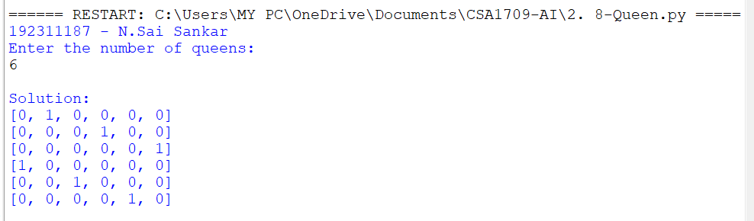

Result:
Hence, the simple python program for 8- Queen problem is done

3. Water Jug

Aim:
To write a python program for water jug problem.

Algorithm:
Step1: Start with two empty jugs of different capacities, and a target quantity of water to measure.
Step2: Fill one jug to its maximum capacity.
Step3: Pour the water from the full jug into the other jug until it is full or the first jug is empty.
Step4: If the second jug is full, pour out the water to empty it.
Step5: Repeat steps 2-4, filling and pouring water between the two jugs, until the desired quantity of water is measured or all possible combinations are tried.
Program:
from collections import deque def water_jug_problem(x, y, z):
"""
Solves the water jug problem using breadth-first search.
x: size of jug 1 y: size of jug 2 z: target amount of water
Returns the sequence of steps to reach the target amount of water.
"""
queue = deque([(0, 0, [])]) # Start with both jugs empty visited = set() while queue:
a, b, steps = queue.popleft()
if (a, b) in visited: continue visited.add((a, b)) if a == z or b == z:
return steps
queue.append((x, b, steps + ['fill jug 1'])) queue.append((a, y, steps + ['fill jug 2'])) queue.append((0, b, steps + ['empty jug 1'])) queue.append((a, 0, steps + ['empty jug 2'])) amount = min(a, y - b)
queue.append((a - amount, b + amount, steps + ['pour jug 1 into jug 2']))
# Pour jug 2 into jug 1 amount = min(x - a, b)
queue.append((a + amount, b - amount, steps + ['pour jug 2 into jug 1'])) return None

steps = water_jug_problem(4, 3, 2) if steps:
print('\n'.join(steps)) else:
print('No solution found.')
OUTPUT:
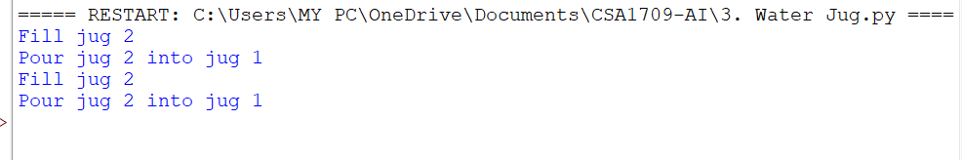
Result:
Hence, the simple python program for water jug problem is done

4. Cript - Arithmetic Problem

Aim:
To write a python program for Cript-Arithematic problem.
Algorithm:
Step 1:Write down the arithmetic problem in full, including any carry-overs.
Step 2: Replace each letter with a unique digit from 0 to 9.
Step 3:Generate all possible combinations of digits for each letter, subject to any constraints ‘ from the carry-overs and the rules of arithmetic.
Step 4: For each combination of digits, evaluate the arithmetic problem and check if it satisfies the given constraints.
Step 5:If a solution is found, output the values of the letters and the arithmetic problem, and exit the algorithm.
Stepm6:If no solution is found, output a message indicating that no solution exists.
Program:
def solve_cryptarithmetic(puzzle):
"""
Solves the cryptarithmetic puzzle.
puzzle: a string containing the puzzle in the form of "WORD + WORD = RESULT" Returns a dictionary mapping letters to digits, or None if no solution is found.
"""
words = puzzle.split() letters = set(''.join(words)) if len(letters) > 10:
return None # More than 10 letters, no solution is possible for perm in permutations(range(10), len(letters)):
mapping = dict(zip(letters, perm))
if all(mapping[word[0]] != 0 for word in words): # Check for leading zeros
- = sum(mapping[c] * (10 ** (len(word) - i - 1)) for word in words for i, c in enumerate(word[::-1]))
- = a // 10 a %= 10
- = sum(mapping[c] * (10 ** (len(words[2]) - i - 1)) for i, c in enumerate(words[2][::-
1]))
if a == mapping[words[2][-1]] and b + c == sum(mapping[c] * (10 ** (len(word) - i - 1)) for word in words[:-1]): return mapping return None # Example usage
puzzle = "SEND + MORE = MONEY"
mapping = solve_cryptarithmetic(puzzle) if mapping:
print(mapping)
print(puzzle.translate(str.maketrans(mapping))) else:
print('No solution found.')

OUTPUT:

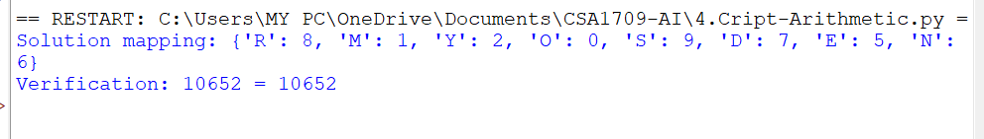

Result:
The output was verified

5. Missionaries Cannibal problem.

Aim:
To write a python program for Missionaries Cannibal problem.

Algorithm:
Step 1: Create a data structure to represent the state of the problem, including the number of missionaries and cannibals on each side of the river and the position of the boat.
Step 2: Create a data structure to represent the state space of the problem, including the initial state, the goal state, and the possible transitions between states.
Step 3: Use a search algorithm, such as depth-first search or breadth-first search, to explore the state space and find a solution.
Step 4: At each step of the search, generate all possible successor states from the current state by applying one of the allowed boat movements (two missionaries, two cannibals, or one of each).
Step 5: Check if the successor state is valid (i.e., no more cannibals than missionaries on either side of the river).
Step 6: If the successor state is valid, add it to the search tree and continue the search.
Step 7: If the successor state is the goal state, return the path from the initial state to the goal state.
Step 8: If there are no more possible successor states to explore, backtrack to the previous state and try another possible movement.

Program:
from typing import List, Tuple from collections import deque def is_valid_state(state: Tuple[int, int, int, int, int, int]) -> bool:
"""
Check if a state is valid according to the problem constraints.
"""
m1, c1, b, m2, c2, _ = state
if m1 < 0 or c1 < 0 or m2 < 0 or c2 < 0:
return False if (m1 > 0 and m1 < c1) or (m2 > 0 and m2 < c2):
return False return True
def get_successors(state: Tuple[int, int, int, int, int, int]) -> List[Tuple[int, int, int, int, int, int]]:
"""
Generate all possible valid states that can be reached from a given state.
"""
m1, c1, b, m2, c2, d = state successors = [] if d == 1:
# boat is on the left side for i in range(3): for j in range(3): if i+j >= 1 and i+j <= 2:
new_state = (m1-i, c1-j, 0, m2+i, c2+j, 1) if is_valid_state(new_state):
successors.append(new_state) else:
# boat is on the right side for i in range(3): for j in range(3): if i+j >= 1 and i+j <= 2:
new_state = (m1+i, c1+j, 1, m2-i, c2-j, 0) if is_valid_state(new_state):
successors.append(new_state)
return successors

def breadth_first_search() -> List[Tuple[int, int, int, int, int, int]]: """
Find the solution using a breadth-first search algorithm.
"""
initial_state = (3, 3, 1, 0, 0, 1) goal_state = (0, 0, 0, 3, 3, 0) visited = set()
queue = deque([(initial_state, [])]) while queue:
state, path = queue.popleft() if state == goal_state: return path + [state] visited.add(state) for successor in get_successors(state): if successor not in visited:
queue.append((successor, path+[state])) return [] if __name__ == '__main__':
solution = breadth_first_search() print("Solution:") for state in solution:
print(state)

Output:
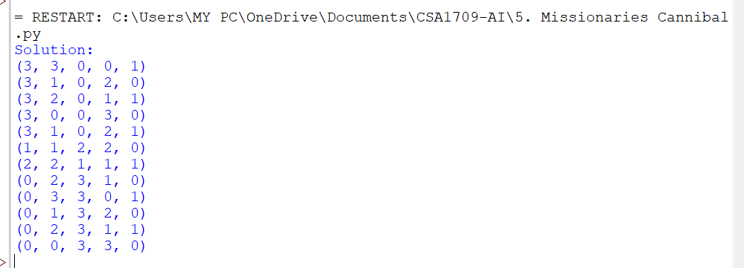

Result:
The program was executed and the output was found to be correct.

6. Vacuum Cleaner Problem.
Aim:
To write a python program for vacuum cleaner problem.
Algorithm:

Step 1: Create a data structure to represent the state of the problem, including the current position of the vacuum cleaner and the state of each square in the room (clean or
dirty).
Step 2: Create a data structure to represent the state space of the problem, including the initial state, the goal state, and the possible transitions between states.
Step 3: Use a search algorithm, such as depth-first search or breadth-first search, to explore the state space and find a solution.
Step 4: At each step of the search, generate all possible successor states from the current state by applying one of the allowed actions (move up, down, left, right, or clean).
Step 5: Check if the successor state is valid (i.e., the vacuum cleaner cannot move outside the room, and it can only clean dirty squares).
Step 6: If the successor state is valid, add it to the search tree and continue the search.
Step 7: If the successor state is the goal state, return the path from the initial state to the goal state.
Step 8: If there are no more possible successor states to explore, backtrack to the previous state and try another possible action.

Program:
from typing import List, Tuple
def get_successors(state: Tuple[Tuple[int, int], List[List[int]]]) -> List[Tuple[Tuple[int, int], List[List[int]]]]: """
Generate all possible valid states that can be reached from a given state.
"""
position, grid = state successors = [] for dx, dy in [(0, 1), (0, -1), (1, 0), (-1, 0)]:
x, y = position
new_x, new_y = x + dx, y + dy if 0 <= new_x < len(grid) and 0 <= new_y < len(grid[0]):
new_grid = [row[:] for row in grid] if new_grid[new_x][new_y] == 1: new_grid[new_x][new_y] = 0
successors.append(((new_x, new_y), new_grid)) return successors def depth_first_search(state: Tuple[Tuple[int, int], List[List[int]]], visited: set) -> bool:
"""
Find the solution using a depth-first search algorithm.
""" if all(all(cell == 0 for cell in row) for row in state[1]):
return True visited.add(state) for successor in get_successors(state): if successor not in visited: if depth_first_search(successor, visited):
return True return False if __name__ == '__main__': grid = [[0, 1, 1, 1], [0, 0, 1, 0],
[1, 0, 0, 1], [1, 1, 1, 0]] initial_state = ((0, 0), grid) if depth_first_search(initial_state, set()): print("The room can be cleaned.") else:
print("The room cannot be cleaned.")
OUTPUT:
Result:
Hence, the simple python program for Vacuum Cleaner Problem was done

7.BFS

Aim:
To write a python program to implement BFS.
Algorithm:
Step 1: Initialize a queue data structure and a set to keep track of visited nodes.
Step 2: Add the starting node to the queue and to the set of visited nodes.
Step 3: While the queue is not empty, dequeue the next node from the queue.
Step 4: For each neighbor of the dequeued node, if it has not been visited yet, add it to the bqueue and mark it as visited.
Step 5: Repeat steps 3-4 until the queue is empty.
Program:
from collections import deque def bfs(adj_list, start, end):
"""
Perform a breadth-first search in the given graph to find the shortest path between the start and end nodes.
"""
queue = deque([(start, [start])]) visited = set() while queue:
node, path = queue.popleft() if node == end: return path if node in visited:
continue
visited.add(node) for neighbor in adj_list[node]: if neighbor not in visited:
queue.append((neighbor, path + [neighbor])) return None if __name__ == '__main__':
graph = {0: [1, 2],
1: [0, 2, 3],
2: [0, 1, 3],
3: [1, 2, 4],
4: [3]} start_node = 0 end_node = 4
shortest_path = bfs(graph, start_node, end_node) if shortest_path is not None:
print(f"The shortest path between {start_node} and {end_node} is {shortest_path}") else:
print(f"There is no path between {start_node} and {end_node}")
Output

Result:
Thus, the was executed and found the output was found to be correct.

8. DFS.

Aim:
To write a python program to implement DFS.
Algorithm:
Step 1: Initialize a set to keep track of visited nodes.
Step 2: Call the DFS-Visit function with the starting node and the set of visited nodes.
Step 3: In the DFS-Visit function, add the current node to the set of visited nodes.
Step 4: For each neighbor of the current node, if it has not been visited yet, recursively call the DFS-Visit function with the neighbor node and the set of visited nodes.
Step 5: Repeat steps 3-4 until all reachable nodes have been visited.
Program:
# Define the graph as an adjacency list graph = {
'A': ['B', 'C'],
'B': ['D', 'E'],
'C': ['F'],
'D': [],
'E': ['F'],
'F': []
}
# Define the DFS function def dfs(graph, start, visited=None): if visited is None: visited = set()
visited.add(start) # mark the node as visited for neighbor in graph[start]: if neighbor not in visited:
dfs(graph, neighbor, visited) # recursively visit unvisited neighbors return visited
# Call the DFS function with starting node 'A' print(dfs(graph, 'A'))
Output :
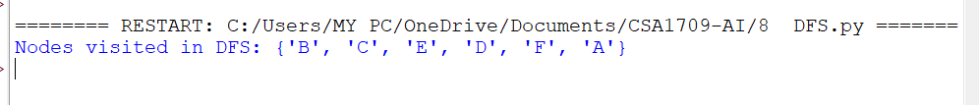
RESULT:
Thus, the Program was executed and output found to be correct.

9. Travelling Salesman Problem.

Aim:
To write a python program to implement travelling salesman problem.
Algorithm:
Step 1: Initialize the best distance and best route to be infinity and an empty list, respectively.
Step 2: Generate every possible permutation of the cities.
Step 3: For each permutation, calculate the distance of the path by summing the distances between each pair of consecutive cities in the permutation.
Step 4: Add the distance from the last city to the first city.
Step 5: If the calculated distance is shorter than the current best distance, update the best distance and best route.
Step 6: Return the best distance and best route.

Program:
import numpy as npdef tsp(cities): # Create a distance matrix n = len(cities)
dist_matrix = np.zeros((n, n)) for i in range(n): for j in range(n): if i != j:
dist_matrix[i][j] = np.linalg.norm(cities[i] - cities[j])
# Initialize variables tour = [0]
unvisited_cities = set(range(1, n)) total_distance = 0
# Find the nearest unvisited city and add it to the tour while unvisited_cities:
current_city = tour[-1]
nearest_city = min(unvisited_cities, key=lambda city: dist_matrix[current_city][city]) tour.append(nearest_city) unvisited_cities.remove(nearest_city)
total_distance += dist_matrix[current_city][nearest_city] # Complete the tour by returning to the starting city tour.append(0)
total_distance += dist_matrix[tour[-2]][0] return tour, total_distance

Output:

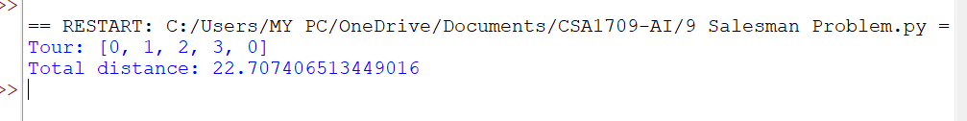

Result:
Thus the Program was executed and the output was found to be Correct.

10. A* algorithm Problem

Aim:
To write a python program to implement A* algorithm.

Algorithm:
Step1 :Initialize the open list with the starting node and the closed list as an empty set. Step 2: Initialize the g score of the starting node to be 0 and the f score of the starting node to be the heuristic estimate of the distance to the goal.
Step 3: While the open list is not empty, select the node with the lowest f score and set it as
the current node.
Step 4: If the current node is the goal node, return the reconstructed path.
Remove the current node from the open list and add it to the closed list.
Step 5: For each neighbor of the current node, calculate the tentative g score as the g score of the current node plus the distance between the current node and the neighbor.
Step 6: If the neighbor is already in the closed list, skip it.
Step 7: If the neighbor is not in the open list, add it and set its g score and f score.
Step 8 :If the neighbor is in the open list but the tentative g score is greater than or equal to
its current g score, skip it.
Step 9 : Otherwise, update the came from dictionary, g score, and f score of the neighbor.
Step 10 : Repeat steps 3-10 until the open list is empty.
If the goal node was never reached, return failure.

Program:
import heapq
def astar(start, goal, neighbors_fn, heuristic_fn):
"""
Find the shortest path from start to goal using A* algorithm.

Arguments:
start: the starting node goal: the goal node neighbors_fn: a function that takes a node and returns its neighbors heuristic_fn: a function that takes a node and returns the estimated
distance to the goal node
Returns:
A tuple containing the path from start to goal and its cost
""" frontier = []
heapq.heappush(frontier, (0, start)) came_from = {} cost_so_far = {}
came_from[start] = None
cost_so_far[start] = 0 while frontier:
_, current = heapq.heappop(frontier)
if current == goal:
break
for neighbor in neighbors_fn(current): new_cost = cost_so_far[current] + 1 if neighbor not in cost_so_far or new_cost < cost_so_far[neighbor]:
cost_so_far[neighbor] = new_cost priority = new_cost + heuristic_fn(neighbor, goal) heapq.heappush(frontier, (priority, neighbor)) came_from[neighbor] = current

path = [goal] current = goal while current != start: current = came_from[current] path.append(current) path.reverse()

return path, cost_so_far[goal]
Output:

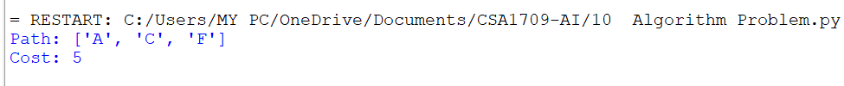
Result:
Thus the Program was executed and the output was found to be Correct.

11. CSP

Aim:
To write a python program for map coloring to implement CSP.

Algorithm:
Initialize an empty assignment for the map coloring problem.
For each country in the map, add a variable X_i to the assignment.
Define the constraints as pairs of adjacent countries, and add a constraint (X_i, X_j) to the CSP such that X_i != X_j.
Define the domain of each variable to be the set of available colors.
Call the Backtrack function to find a consistent assignment for the variables.
In the Backtrack function, check if the assignment is complete. If it is, return the assignment.
Select an unassigned variable X_i from the assignment.
For each value v in the domain of X_i, check if it is consistent with the constraints and the assignment so far.
If it is, assign X_i = v to the assignment and recursively call Backtrack with the new assignment.
If the result of Backtrack is not a failure, return the result.
If the result is a failure, remove the assignment X_i = v and try the next value in the domain.
If all values in the domain have been tried and failed, return failure.
Program:
from typing import Dict, List from itertools import product from copy import deepcopy class CSP: def __init__(self, variables: List[str], domains: Dict[str, List[str]], constraints):
self.variables = variables self.domains = domains self.constraints = constraints

def solve(self): assignments = {} return self.backtrack(assignments)

def backtrack(self, assignments): if len(assignments) == len(self.variables):
return assignments

var = self.select_unassigned_variable(assignments) for value in self.order_domain_values(var, assignments):
new_assignments = deepcopy(assignments) new_assignments[var] = value if self.is_consistent(new_assignments):
result = self.backtrack(new_assignments)
if result is not None:
return result

return None

def select_unassigned_variable(self, assignments): for var in self.variables:
if var not in assignments:
return var

def order_domain_values(self, var, assignments):
values = self.domains[var]
return sorted(values, key=lambda value: self.get_num_conflicts(var, value, assignments))

def get_num_conflicts(self, var, value, assignments):
conflicts = 0 for constraint in self.constraints: if var in constraint and len(constraint) == 2:
other_var = constraint[0] if constraint[1] == var else constraint[1] if other_var in assignments and assignments[other_var] == value:
conflicts += 1
return conflicts

def is_consistent(self, assignments): for constraint in self.constraints: if all(var in assignments for var in constraint): if not self.satisfies_constraint(assignments, constraint):
return False
return True

def satisfies_constraint(self, assignments, constraint): if len(constraint) == 2: val1, val2 = assignments[constraint[0]], assignments[constraint[1]]
return val1 != val2
else:
return True

def map_coloring():
variables = ['WA', 'NT', 'SA', 'Q', 'NSW', 'V', 'T'] domains = {
'WA': ['r', 'g', 'b'],
'NT': ['r', 'g', 'b'],
'SA': ['r', 'g', 'b'],
'Q': ['r', 'g', 'b'],
'NSW': ['r', 'g', 'b'],
'V': ['r', 'g', 'b'],
'T': ['r', 'g', 'b']
}
constraints = [ ('WA', 'NT'),
('WA', 'SA'),
('NT', 'SA'),
('NT', 'Q'),
('SA', 'Q'),
('SA', 'NSW'),
('SA', 'V'),
('Q', 'NSW'),
('NSW', 'V')
]
csp = CSP(variables, domains, constraints) result = csp.solve() if result is not None:
print(result) else:
print("No solution found")

map_coloring() output:
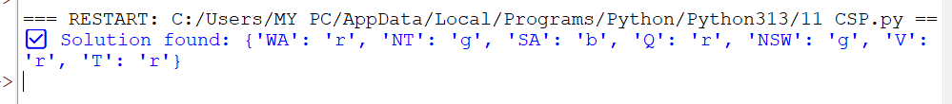

Result:
Hence, the simple python program for Map Coloring to implement CSP is done

12. Tic Tac Toe game

AIM:
To develop a command-line, two-player Tic-Tac-Toe game in Python where players alternate turns placing 'X' and 'O' on a 3x3 grid, with the program automatically detecting wins or draws.

Algorithm:

- Board Representation: The grid is represented by a single list of 9 string spaces.
- Visual Rendering: The print_board function formats the list into a visual 3x3 layout.
- Turn Management: Players 1 (X) and 2 (O) automatically alternate turns inside a continuous while loop.
- Input Handling: The program converts a 1–9 user choice into a 0–8 list index to place the icon.
- Collision Prevention: An if statement checks if a spot is empty before allowing a move.
- Condition Checking: The code explicitly scans 8 winning lines or checks for a full board after every turn.

Program:
# Tic Tac Toe game
board = [' ' for _ in range(9)]

def print_board():
row1 = '|'.join(board[0:3]) row2 = '|'.join(board[3:6]) row3 = '|'.join(board[6:9]) print(row1)
print('-' * 5)
print(row2)
print('-' * 5)
print(row3)

def player_move(icon):
if icon == 'X': player = 1 else:
player = 2

print("Player {}'s turn".format(player))

choice = int(input("Enter your move (1-9): ").strip()) if board[choice-1] == ' ': board[choice-1] = icon
else:
print("That space is already taken!")

def is_victory(icon):
if (board[0] == icon and board[1] == icon and board[2] == icon) or \ (board[3] == icon and board[4] == icon and board[5] == icon) or \
(board[6] == icon and board[7] == icon and board[8] == icon) or \
(board[0] == icon and board[3] == icon and board[6] == icon) or \
(board[1] == icon and board[4] == icon and board[7] == icon) or \
(board[2] == icon and board[5] == icon and board[8] == icon) or \
(board[0] == icon and board[4] == icon and board[8] == icon) or \
(board[2] == icon and board[4] == icon and board[6] == icon):
return True else:
return False

def is_draw():
if ' ' not in board: return True else:
return False

while True: print_board() player_move('X')
if is_victory('X'):
print("X Wins! Congratulations!")
break elif is_draw():
print("It's a Draw!") break
print_board() player_move('O')
if is_victory('O'):
print("O Wins! Congratulations!")
break elif is_draw():
print("It's a Draw!") break

OUTPUT:
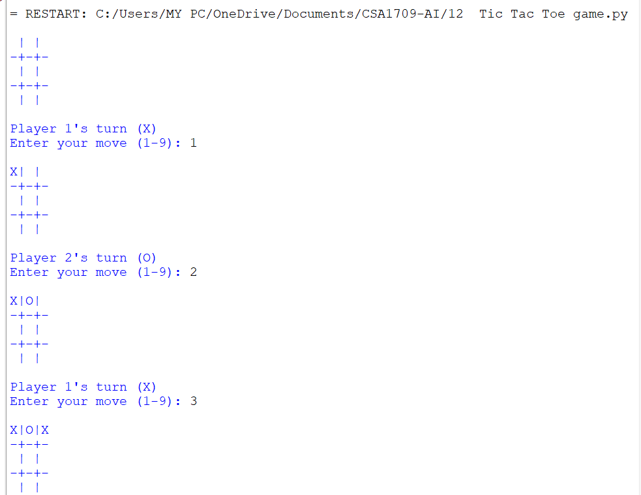

Result:
Hence, the simple the python program for Tic Tac Toe game is done.

